**Objectives**

**This lab creates a topology using dynamic routing and demonstrates ow routers choose between competing routes.**

* Ensure you’ve reviewed the lecture slides, module videos and textbook first.
* Read over the entire lab before proceeding and follow instructions carefully. Do not make assumptions.
* Per the lecture slides, it may be helpful to draw the topology diagram first and label the ports and subnet addresses.
* When configuring PC’s don’t forget to configure the gateway address and to use the correct subnet mask.
* It is best to start with an empty topology rather than using an existing one and reconfiguring all the devices to new addresses.
* For the routers, use 4331 and configured with 3 ports.
* Open a textbox for lab answers.
* Do not over configure!

**A - Create the Initial Topology**  
 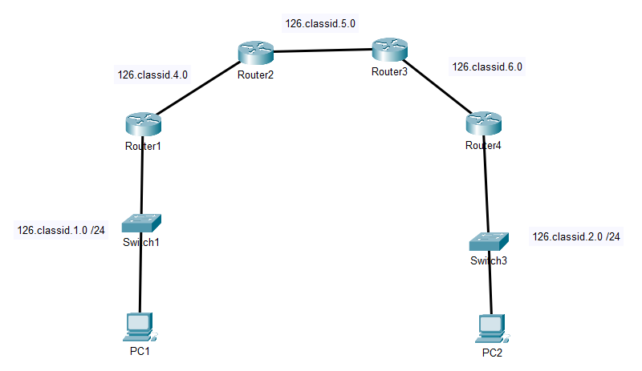

* Add a textbox with your name, Class ID , and “LAB 08B”
* Note: Use a 4331 Router configured with 3 ports
* Connect the switches to the router’s port 0
* Add textboxes to label each subnet. Add a textbox to indicate the PC’s IP addresses

**B – Configure the Subnets**

|  |  |  |  |
| --- | --- | --- | --- |
| **Router** | **Port** | **IP Address** |  |
| R1 | 0 |  |  |
|  | 1 |  |  |
|  | 2 |  |  |
| R2 | 0 |  |  |
|  | 1 |  |  |
|  | 2 |  |  |
| R3 | 0 |  |  |
|  | 1 |  |  |
|  | 2 |  |  |
| R4 | 0 |  |  |
|  | 1 |  |  |
|  | 2 |  |  |

**C – Configure Routers with RIPv2**

* Configure each router with RIPv2
* *Note: turn on the RIP simulation filter to watch (and debug) how the routers share information*
* Ensure you can ping from PC1 to PC2 successfully.
* On R1, enter “SHOW IP ROUTE RIP” to view only the RIP routes. Copy the route display for the subnet 126.*yourid.*2.0. It should look something like:   
   R 126.0.2.0/24 [120/3] via 126.0.4.2, 00:00:17, GigabitEthernet0/0/1
* QUESTIONS for the textbox:   
  1. Copy and paste the single line like the above   
  2. Explain what the two numbers in the third column (ex: [120/3]) mean. Be specific!

**D – Add a Completing Route**

* Ensure you are in SIMULATION mode, and turn the RIP filter on.
* Add a cable connecting R1 to R4 and configure it as another subnet. (See below)
* Configure RIP on R1 and R4 to use the new network.
* Forward time on the simulation to watch the RIP packets share the new route
* Ping from PC1 to PC2. In time, the packet should use the new route.

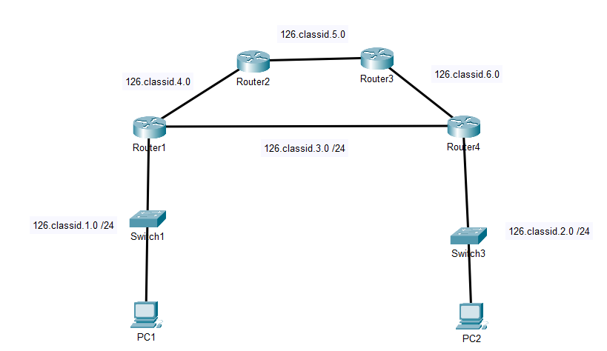

* On R1, enter “SHOW IP ROUTE RIP” to view only the RIP routes. Copy the route display for the subnet 126.*yourid.*2.0. It should look similar – but different – from the previous command response.
* QUESTIONS for the textbox:   
  3. Copy and paste the new response line for subnet 126.*yourid*.2.0   
  4. What has changed?  
  5. Explain what the two numbers in the third column (ex: [120/3]) now mean.   
  6. What is the term that describes when a topology changes?
* To watch RIP in action, shutdown one of the ports on the 126.*yourid*.3.0 network. RIP should reconfigure the topology to use the original route again.
* Turn that port back on.

**E – Lab Completion**

* Save your PKT file : L09B-*lastname*.PKT.
* Submit only the PKT file in iLearn. *You do not have to write up a lab for this week.*